  

## KARNATAKA STATE COUNCIL FOR SCIENCE AND TECHNOLOGY

*Indian Institute of Science campus, Bengaluru*

Telephone: 080 -23600978, 23341652 || Email: [spp@kscst.org.in](mailto:spp@kscst.org.in) Website: [www.kscst.iisc.ernet.in/spp.html](http://www.kscst.iisc.ernet.in/spp.html) or [www.kscst.org.in/spp.html](http://www.kscst.org.in/spp.html)

**FORMAT FOR STUDENT PROJECT PROPOSAL FOR THE 46th SERIES OF STUDENT PROJECT PROGRAMME**

(Handwritten proposals will not be accepted, please fill all the details in this MS word file, insert images / diagrams wherever necessary. Convert to pdf file, get it approved from the project guide / head of the department and principal of your institution. Keep ready the scanned pdf file of 1) Declaration and Endorsement 2) details of processing fees made and fill-up the Google Form. Send the softcopy of the project proposal including the three scanned pages and send the proposal (All information in one pdf file) by email to [spp@kscst.org.in](mailto:spp@kscst.org.in)

https://forms.gle/pMfzw4iKL7LNAojd8

|  |  |
| --- | --- |
| **1.** | **Name of the College:**  **GSSS Institute of Engineering and Technology for Women, Mysuru** |
| **2.** | **Project Title:**  **Detection and monitoring of current leakage in power transmission line insulator using IoT.** |
| **3.** | **Branch:**  **Electrical and Electronics Engineering** |
| **4.** | **Theme (as per KSCST poster):**  **Stream No. 1) Non Conventional and Composite building materials/structures** |
| **5.** | **Name(s) of project guide(s):**  **1. Name: Prof. Smitha S K**  **Email id:** [**smitha**](mailto:smithak@gsss.edu.in)[**k@gsss.edu.in**](mailto:k@gsss.edu.in) **Contact No: 9449307538** |

|  |  |
| --- | --- |
| **6.** | **Name of Team Members (Strictly not more than four students in a batch):**  **Name: GANAVI**  **USN No: 4GW19EE013**  **Email id:** [**ganavigsg@gmail.com**](mailto:ganavigsg@gmail.com) **Mobile No:8105466243**  **Name: HIMASHREE H S USN No: 4GW19EE015**  **Email id:** [**himashreehs01@gmail.com**](mailto:himashreehs01@gmail.com) **Mobile No: 7349415389**  **Name: RENUKA S MANNERI USN No: 4GW19EE033**  **Email id:** [**renukamanneri7@gmail.com**](mailto:renukamanneri7@gmail.com) **Mobile No:8088263237**  **Name: TEJASHREE S USN:4GW19EE038**  **Email id:** [**shreeteja929@gmail.com**](mailto:shreeteja929@gmail.com) **Mobile No: 9353273537** |

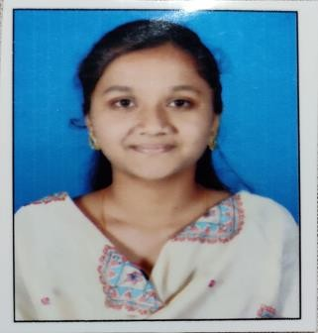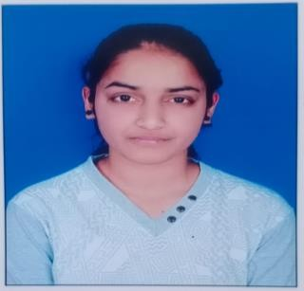

|  |  |
| --- | --- |
| **7.** | **Team Leader of the Project:**  **Name: RENUKA S MANNERI USN No: 4GW19EE033**  **Email id:** [**renukamanneri7@gmail.com**](mailto:renukamanneri7@gmail.com) **Mobile No:8088263237** |
| **8.** | **Processing Fee Details (Through Online Payment only):**  **(processing fee of Rs. 1000/-)**  **Please furnish the payment made details provided in the last page of this proposal.**  UPI No: 000394063218  Date: 31/01/2023  Bank Name: CANARA BANK |
| **9.** | **Date of commencement of the Project: 02/11/2022** |
| **10.** | **Probable date of completion of the project: 20/2/2023** |
| **11.** | **Scope / Objectives of the project:**   * Measuring, monitoring and Analysis of leakage current in transmission line insulators. * Monitoring of humidity, leakage current and temperature. * Interface to obtain the output using IOT technology. |
| **12.** | **Methodology:** |



|  |  |
| --- | --- |
|  | * Insulators are placed in the overhead transmission lines. * As leakage current is one of the factors that affect insulators. Its monitoring is required. * There is a need to monitor the condition of such equipment and possibly extend service life in the absence of major system disruptions. * Leakage current is monitored by Hall Effect Sensor. * The other parameters such as the temperature and humidity of the insulator are monitored by sensors and the values are displayed in the LCD unit. * Arduino and Node-MCU are used to analyze data and transmit information very quickly. * The location of the fault is transferred to the concerned people and the amount of leakage current can be identified through IoT technology. |
| **13.** | **Expected Outcome of the project:**  In this project, a new technology is proposed for data transmission about the leakage current through IOT to mobile phones and substation. Required analysis of leakage current in transmission line insulators is measured by monitoring humidity, leakage current, temperature and speed. The output is obtained by interfacing. It is efficient, easy installation, robust and reliable to electrical system and it is necessary to transform the data into information. |
| **14.** | **Is the project proposed relevant to the Industry / Society or Institution?**  **Yes / No: No** |

|  |  |  |  |  |
| --- | --- | --- | --- | --- |
| **15.** | **Can the product or process developed in the project be taken up for filing a Patent?**  **Yes / No:**  **No**  **Prior Art search done? Yes/No:**  **No** | | | |
| **16.** | **Budget details (break-up details should be given):**  Note: KSCST will provide nominal grant support for carrying out the project by students if selected by the project selection committee. | | | |
|  | **Budget** | **Amount** |  |
| a) Materials / Consumables (Please specify) | 2500.00 |
| b) Labor (Describe) | 1500.00 |
| c) Travel (Describe) | 500.00 |
| e) Miscellaneous (Please specify) | 500.00 |
| **Total** | 5000.00 |
| **17.** | **Any other technical details (Please specify):**  Hardware Components:   * Hall effect Sensor * PIC Microcontroller * Temperature Sensor * Liquid Crystal display(LCD) Software used: * IoT | | | |
| **18.** | **SPP Coordinator (Identified by the college):**  **Note:** To be identified by the principal of the institution. The project proposals must be submitted to KSCST through SPP coordinator designated by the principal.  **Name: Mr.RAJASHEKAR M B**  **Email id:** [**rajashekar@gsss.edu.in**](mailto:rajashekar@gsss.edu.in) **Contact No.: 9620268281** | | | |

**Name of the Project Guide: Smt. Smitha S K Name of the HOD: Dr.G.Sreeramulu Mahesh Email ID:** [**smithak@gsss.edu.in**](mailto:smithak@gsss.edu.in) **Email** [**ID:hodeee@gsss.edu.in**](mailto:hodeee@gsss.edu.in)

**Contact No: 9449307538 Contact No: 9980147498**



**DEPARTMENT OF ELECTRICAL AND ELECTRONICS ENGINEERING**

# DECLARATION

**(From Project Students)**

We, the project team hereby declare that the details enclosed in the project proposal (Title of the Project: Detection and monitoring of current leakage in Transmission lines using IOT Technology, Branch: Electrical & Electronics Engineering, College: GSSS Institute of Engineering & Technology for Women, Mysuru, are true and correct to the best of our knowledge and belief and we undertake to inform KSCST of any changes therein in the project title, students name will be intimated immediately through project guide. In case any of the above information is found to be false or untrue or misleading, we are aware that we may be held liable for it. We hereby authorize sharing of the project information with this project proposal with the Karnataka State Council for Science and Technology, Bangaluru.

We are aware that the project team must exhibit / demonstrate the project in the nodal centre and interact regarding project with the experts and to exhibit the project in the State Level Seminar and Exhibition (if selected). If the student team fails to attend the evaluation in nodal centre or fails to attend the State Level Seminar and Exhibition, the supported project amount will be returned to KSCST.

We also hereby, enclose the endorsement form to KSCST, Bengaluru.

**Name of the students with USN No. Signature with date**

1. Ganavi G (4GW19EE013)
2. Himashree H S (4GW19EE015)
3. Renuka S Manneri ( 4GW19EE033)
4. Tejashree S (4GW19EE038)

|  |  |
| --- | --- |
| **Smt.Smitha.S.K**  **(Name & Signature of Project Guide with Seal)** | **Dr.G.Sreeramulu Mahesh**  **(Name & Signature of HOD with Seal)** |
| **Email id:** [**smithak@gsss.edu.in**](mailto:smithak@gsss.edu.in) | **Email id:** [**hodeee@gsss.edu.in**](mailto:hodeee@gsss.edu.in) |
| **Contact No: 9449307538** | **Contact No: 9980147498** |

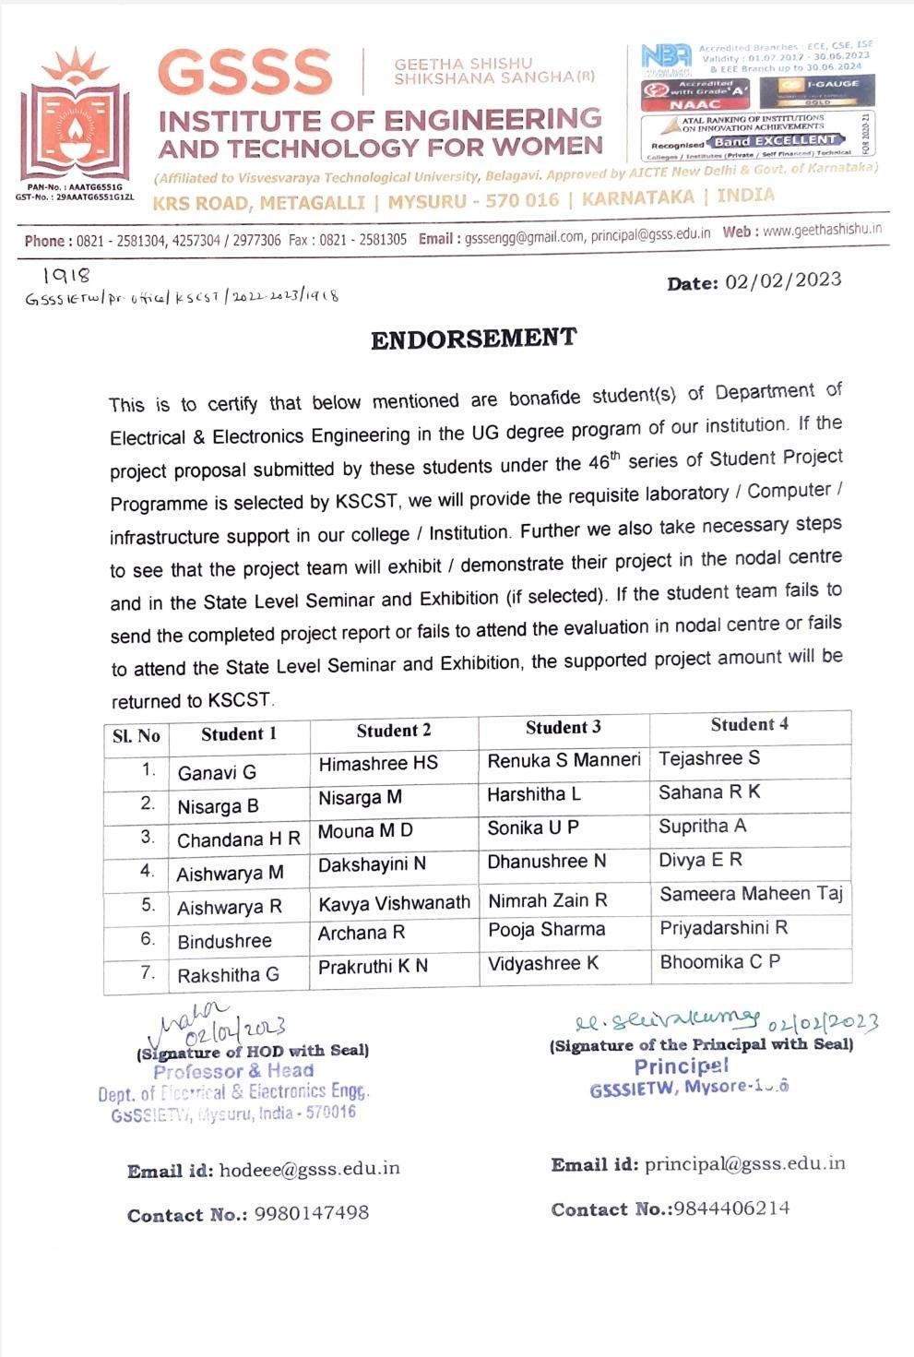

**DETAILS OF PROCESSING FEES MADE THROUGH NEFT / UPI PAYMENT**

(**Note:** Include this page in the softcopy of the student project proposal. The student team shall furnish the details in the Google Form. It is informed to the students to 1) keep ready the softcopy of the project proposal and other documents and 2) Furnish the payment made details as processing fees and 3) update the details in the Google Form on the same day of payment made to KSCST by NEFT / UPI payment).

|  |  |  |
| --- | --- | --- |
| 1. TITLE OF THE PROJECT | : | Detection and monitoring of current leakage in power transmission line insulator using IoT |
| 2. NAME OF THE TEAM LEADER | : | Renuka S Manneri |
| 3. EMAIL ID | : | [renukamanneri7@gmail.com](mailto:renukamanneri7@gmail.com) |
| 4. CONTACT MOBILE NO. | : | 8088263237 |

**PAYMENT MADE DETAILS**

|  |  |  |
| --- | --- | --- |
| 5. BANK REF. NO. / UTR NO. / UPI No. (12 digits) | : | 000394063218 |
| 6. TRANSACTION ID | : | 000394063218 |
| 7. NAME OF THE SENDER / ACCOUNT HOLDER and CONTACT NUMBER | : | Principal, GSSSIETW |
| 8. NAME OF THE BANK | : | CANARA BANK |
| 9. PROCESSING FEES | : | Rs. 1000/-(36,000 for 36 project proposals) |
| 10. DATE OF PAYMENT MADE | : | 31-01-2023 |
| 11. TIME | : | 12:02:44 |
| 12. MODE OF PAYMENT MADE (NEFT / UPI, PLEASE SPECIFY) | : | Funds Transfer Debit-KARNATAKA STATE COUNCIL FOR SCIENCE: Cheque |

|  |  |
| --- | --- |
| **Renuka S Manneri**  (Name & Signature of the team leader) | **Dr.G.Sreeramulu Mahesh**  (Name & Signature of Project Guide or HOD with Seal) |

## KARNATAKA STATE COUNCIL FOR SCIENCE AND TECHNOLOGY

Indian Institute of Science campus, Bengaluru

**46th SERIES OF STUDENT PROJECT PROGRAMME (SPP)**

***(Note: This page is for information about bank details of KSCST to the student team and college / institution and not to include this page in the project proposal softcopy)***

# BANK ACCOUNT DETAILS OF KSCST

|  |  |
| --- | --- |
| Name and address of the Institution | Karnataka State Council for Science and Technology, IISc Campus, Bangalore -560012 |
| Account holder’s name /  Designation | Secretary, Karnataka State Council for Science and Technology |
| Bank Account No. & Name of the bank | Current A/C No. 0683201000024  Canara Bank, IISc Campus Branch, Bangalore-560012 |
| IFSC Code | CNRB0000683 |
| MICR Code | 560015023 |
| Bank Branch Address | Canara Bank, Indian Institute of Science, Bangalore-560012 |

